Wireshark Lab 2: UDP

Group Details:
Qianhao ZHANG / 1004654377
Zhaoning KONG / 1004654288

Mark:

 | Question | Answer
1 | Select one packet. From this packet, determine how many fields there are in the UDP header. Name these fields. | 4.  Source Port.  Destination Port.  Length.  Checksum.  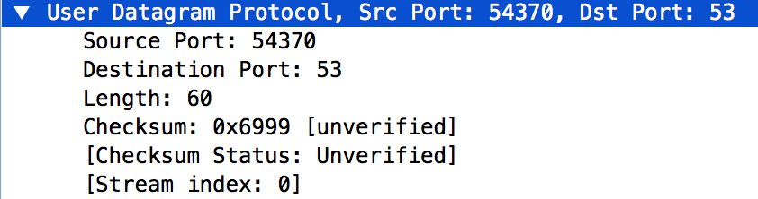
2 | From the packet content field, determine the length (in bytes) of each of the UDP  header fields. | 8 bytes.  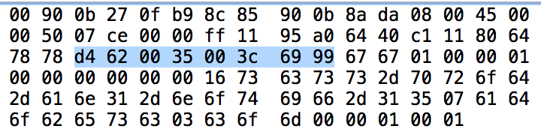
3 | The value in the Length field is the length of what? Verify your claim with your  captured UDP packet. | The length of the packet starting from UDP header. In this case the length of UDP header and DNS header.  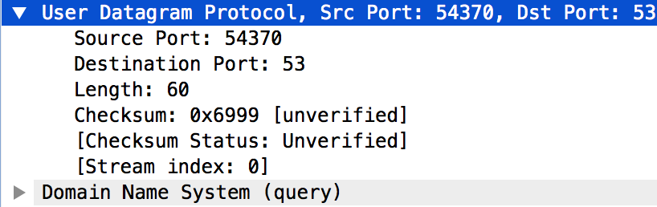  UDP header starts with ‘d4’, DNS ends with ‘01’. Altogether they do make 60 bytes.
4 | What is the maximum number of bytes that can be included in a UDP payload. | The length field is 2-byte long, so the maximum length is 2^16 – 1 bytes, and the payload can only make use of the part without the header, so 2^16 – 1 – 8 = 65527B.
5 | What is the largest possible source port number? | The field is 2-byte long, so the maximum is 2^16 – 1 = 65535.
6 | What is the protocol number for UDP? Give your answer in both hexadecimal and decimal notation. (To answer this question, you’ll need to look into the IP  header.) |   (hex) 0x11.  (decimal) 17.
7 | Search “UDP” in Google and determine the fields over which the UDP checksum is calculated. | TCP header: Source, Destination, Protocol  UDP header: Length
8 | Examine a pair of UDP packets in which the first packet is sent by your host and the second packet is a reply to the first packet. Describe the relationship between  the port numbers in the two packets | The source port of the first packet is the destination port of the second packet.  The destination port of the first packet is the source port of the second packet.  